Week-6
Q1: Explain the roles of the Driver, Cluster Manager, and Executor in a Spark application.
Q2: How does Spark’s Lazy Evaluation strategy improve performance when chain-processing large datasets?
Q3: Write a Spark command to read a CSV file located at "data/source.csv", ensuring the first row is treated as a header and inferSchema is enabled.
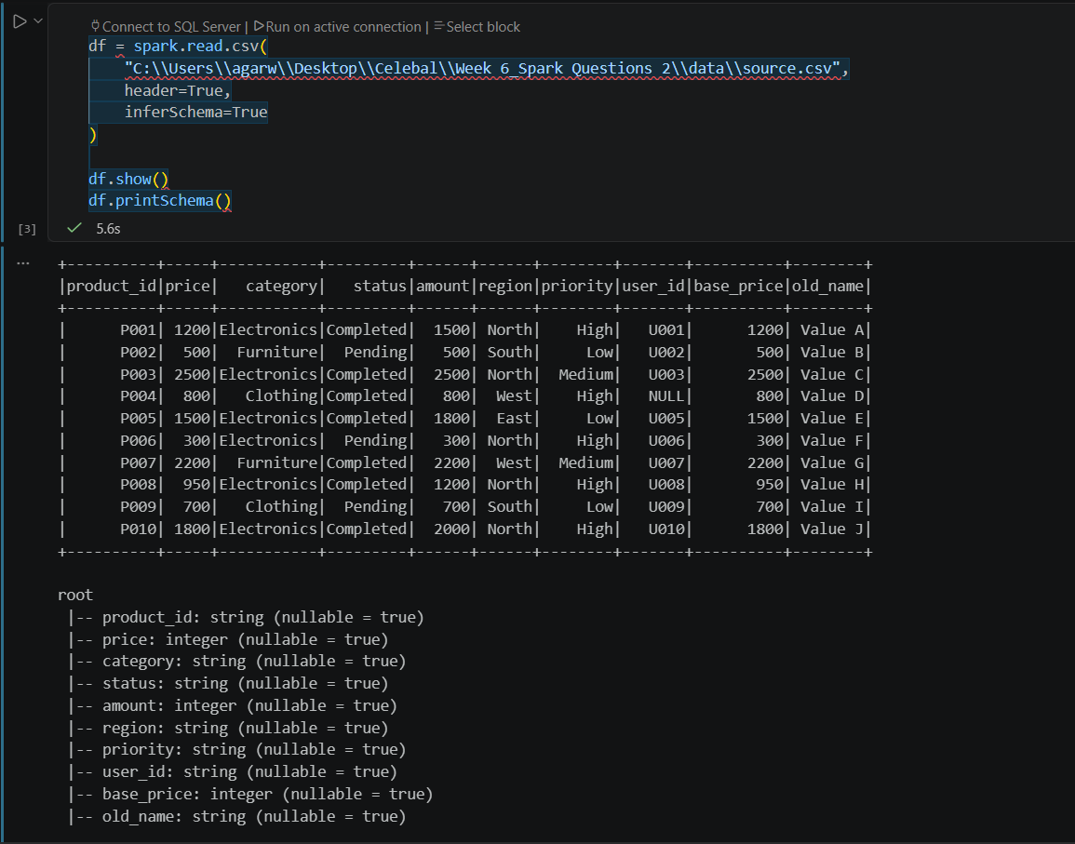
Q4: What is the difference between CSV and Parquet in terms of storage (row-based vs. columnar) and why does it matter for performance?

Q5: Given a DataFrame df, write a query to select the columns product_id and price where the category is 'Electronics'.
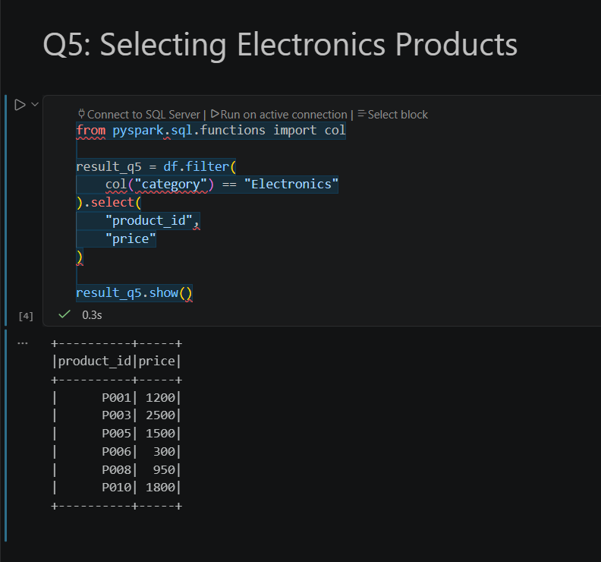
Q6: Write the code to "revise" a DataFrame by renaming the column old_name to new_name and casting the price column from a String to a Double.
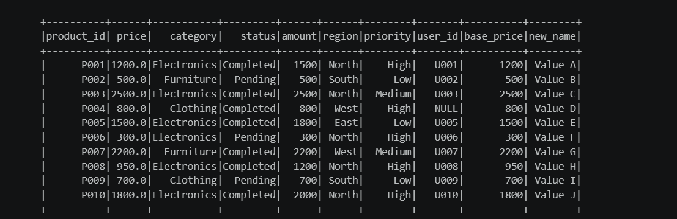
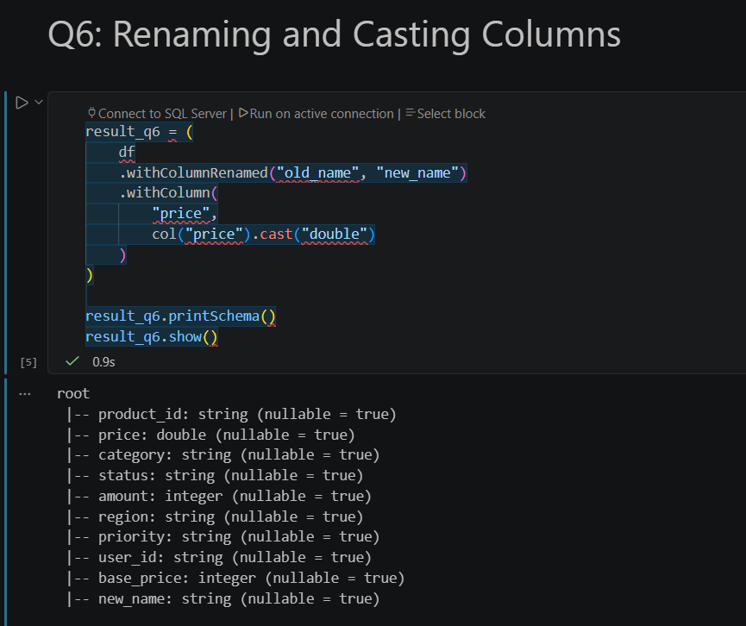
Q7: How does Spark use the Lineage Graph (DAG) to provide fault tolerance if a worker node fails?
Q8: Write a query to filter a DataFrame df_orders for rows where the status is 'Completed' AND the amount is greater than 1000.
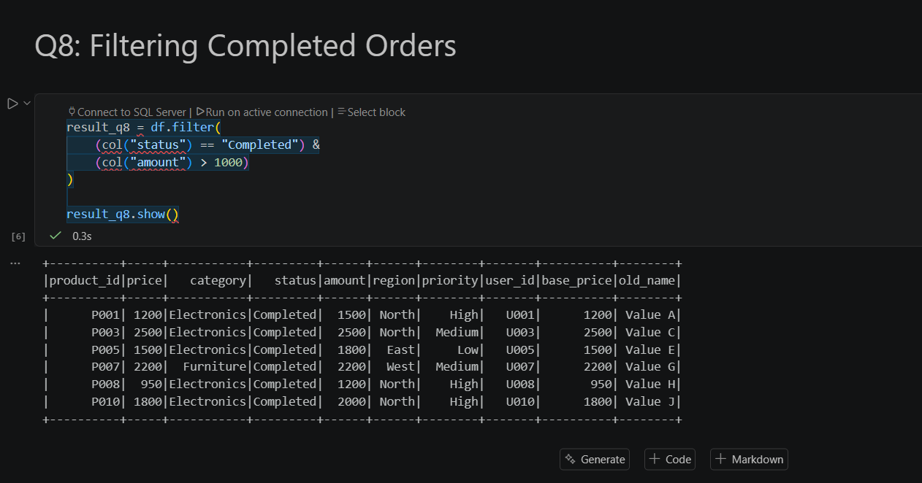
Q9: Explain the concept of Predicate Pushdown in Parquet and how it affects the amount of data loaded into memory.
Q10: Write a code snippet to add a new column final_price which is the base_price multiplied by 1.18 (18% tax).
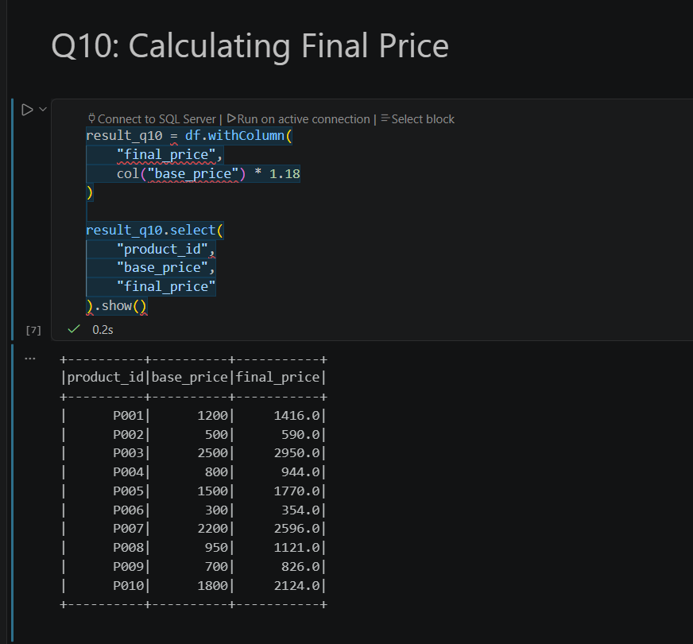

Q11: What is the difference between Transformations and Actions? Provide two examples of each.
Q12: Write the Spark command to load a Parquet file from "path/to/input", filter out any rows where user_id is null, and save the result as a CSV at "path/to/output".
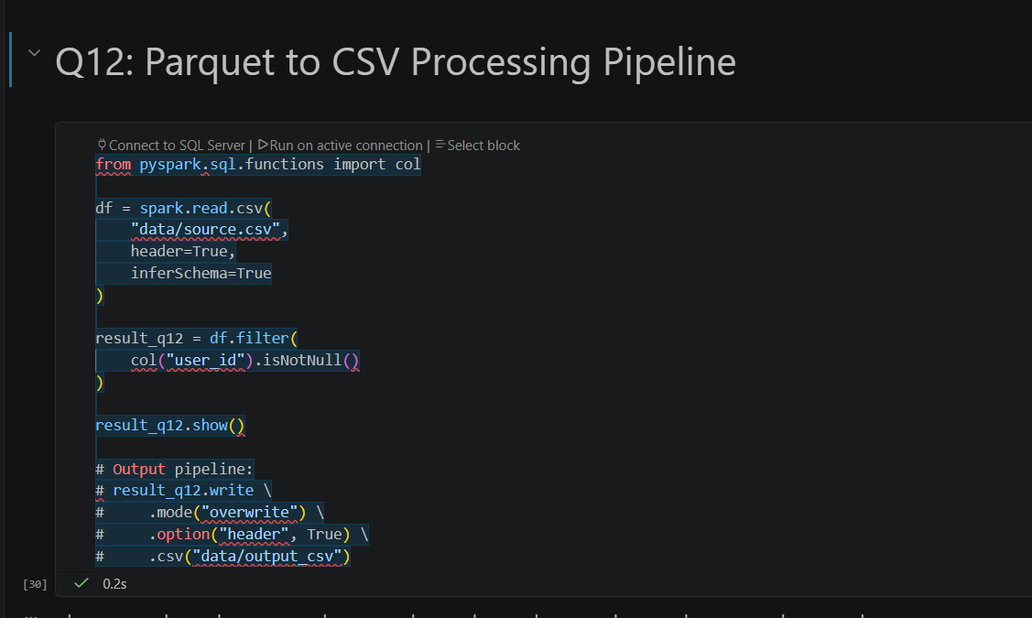
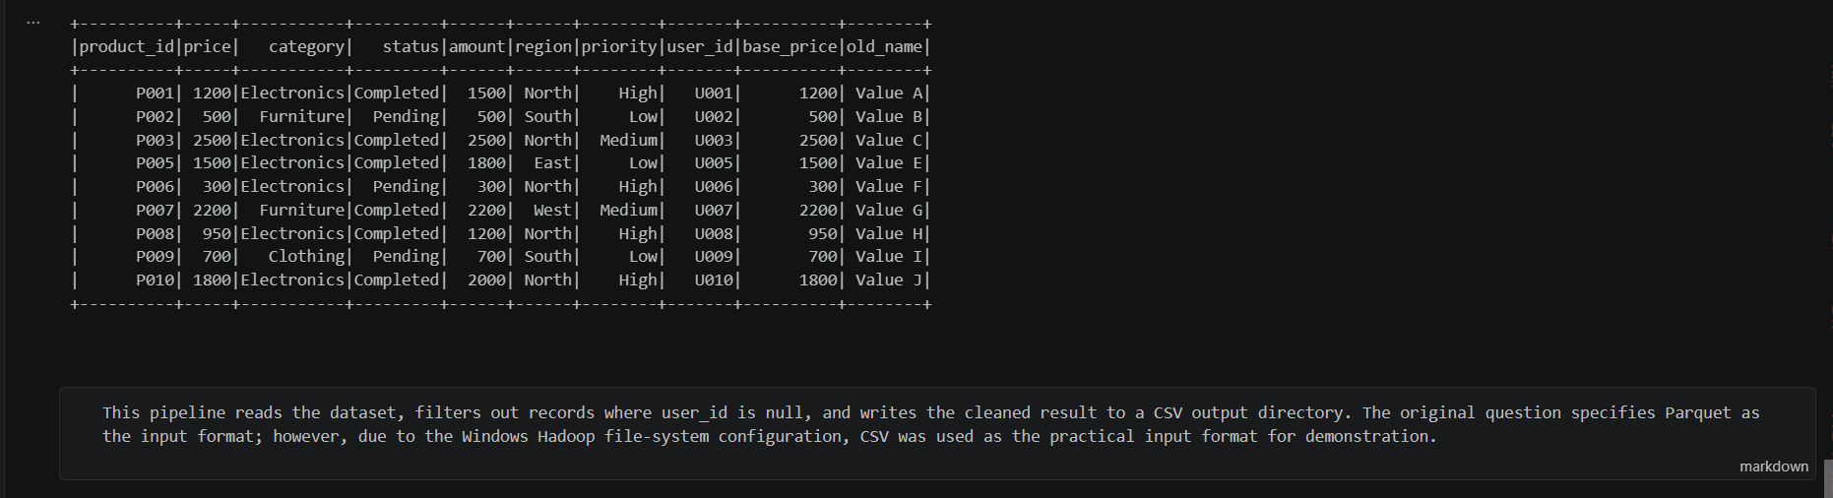

Q13: In Spark Architecture, what is the difference between Client Mode and Cluster Mode?
Q14: Write a query to filter a dataset for rows where the region is 'North' OR the priority is 'High'.
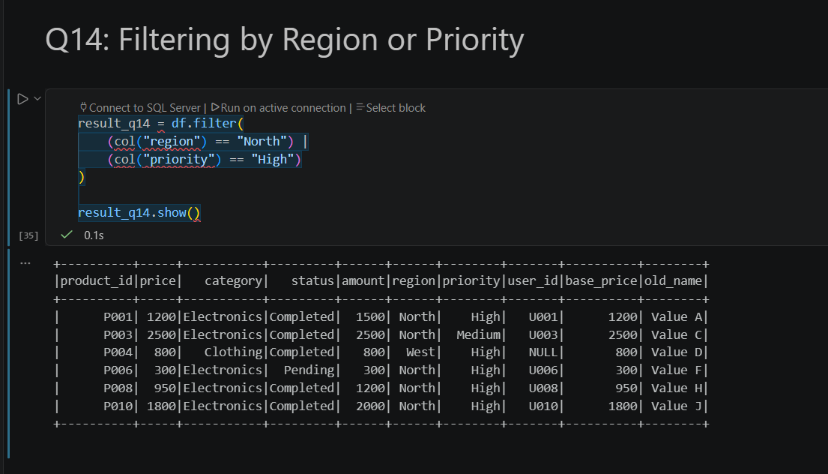
Q15: When exploring a dataset, why is it safer to use .show(5) instead of .collect() on a multi-terabyte dataset?

